**Nama : Imbar**

**Kelas : FSWD3**

**Github**

**Link Github :** [ImbarInformatika/tugas2-fswd-arkatama (github.com)](https://github.com/ImbarInformatika/tugas2-fswd-arkatama)

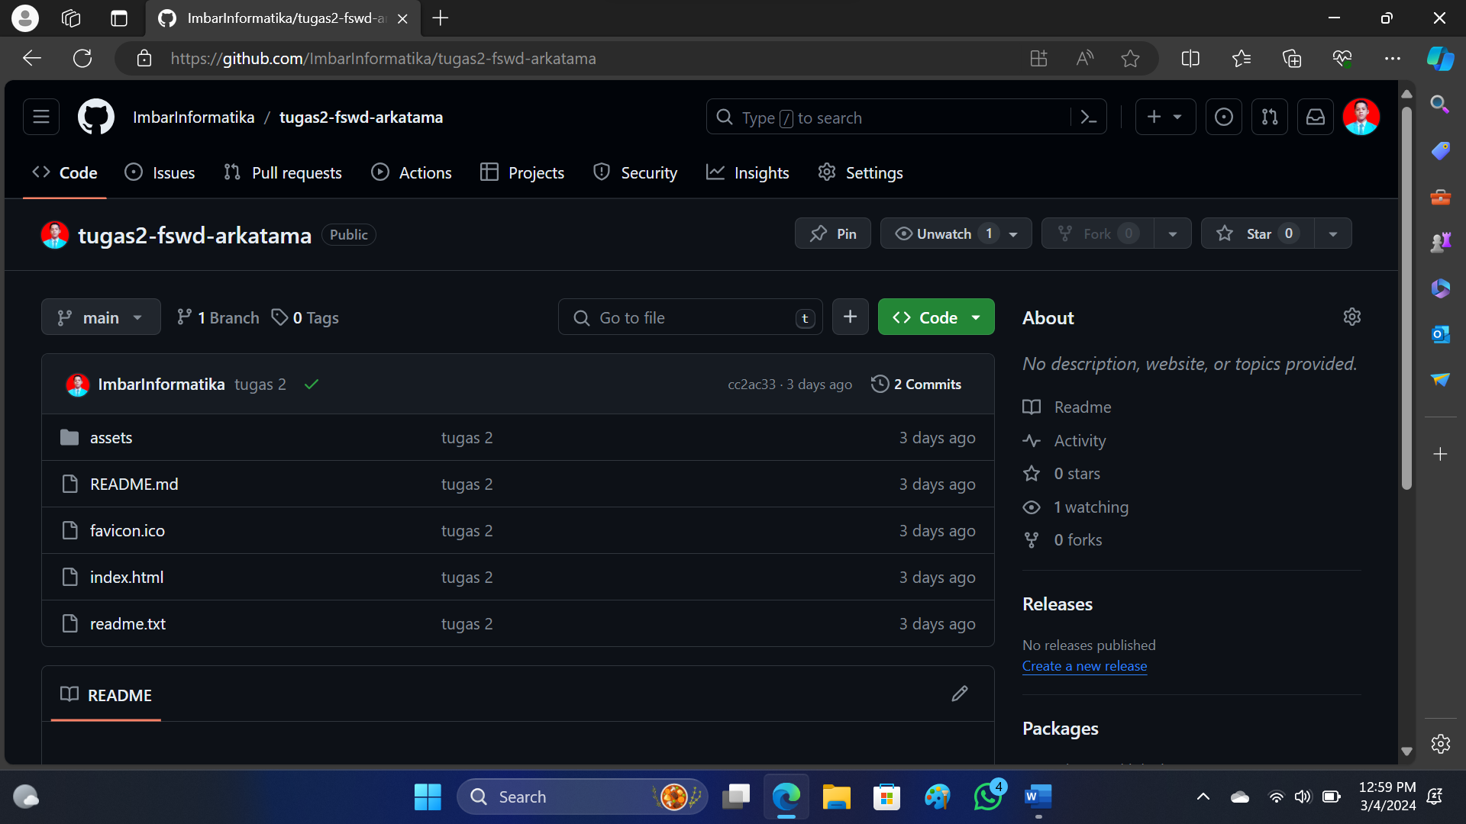

**Tampilan Githubpage**

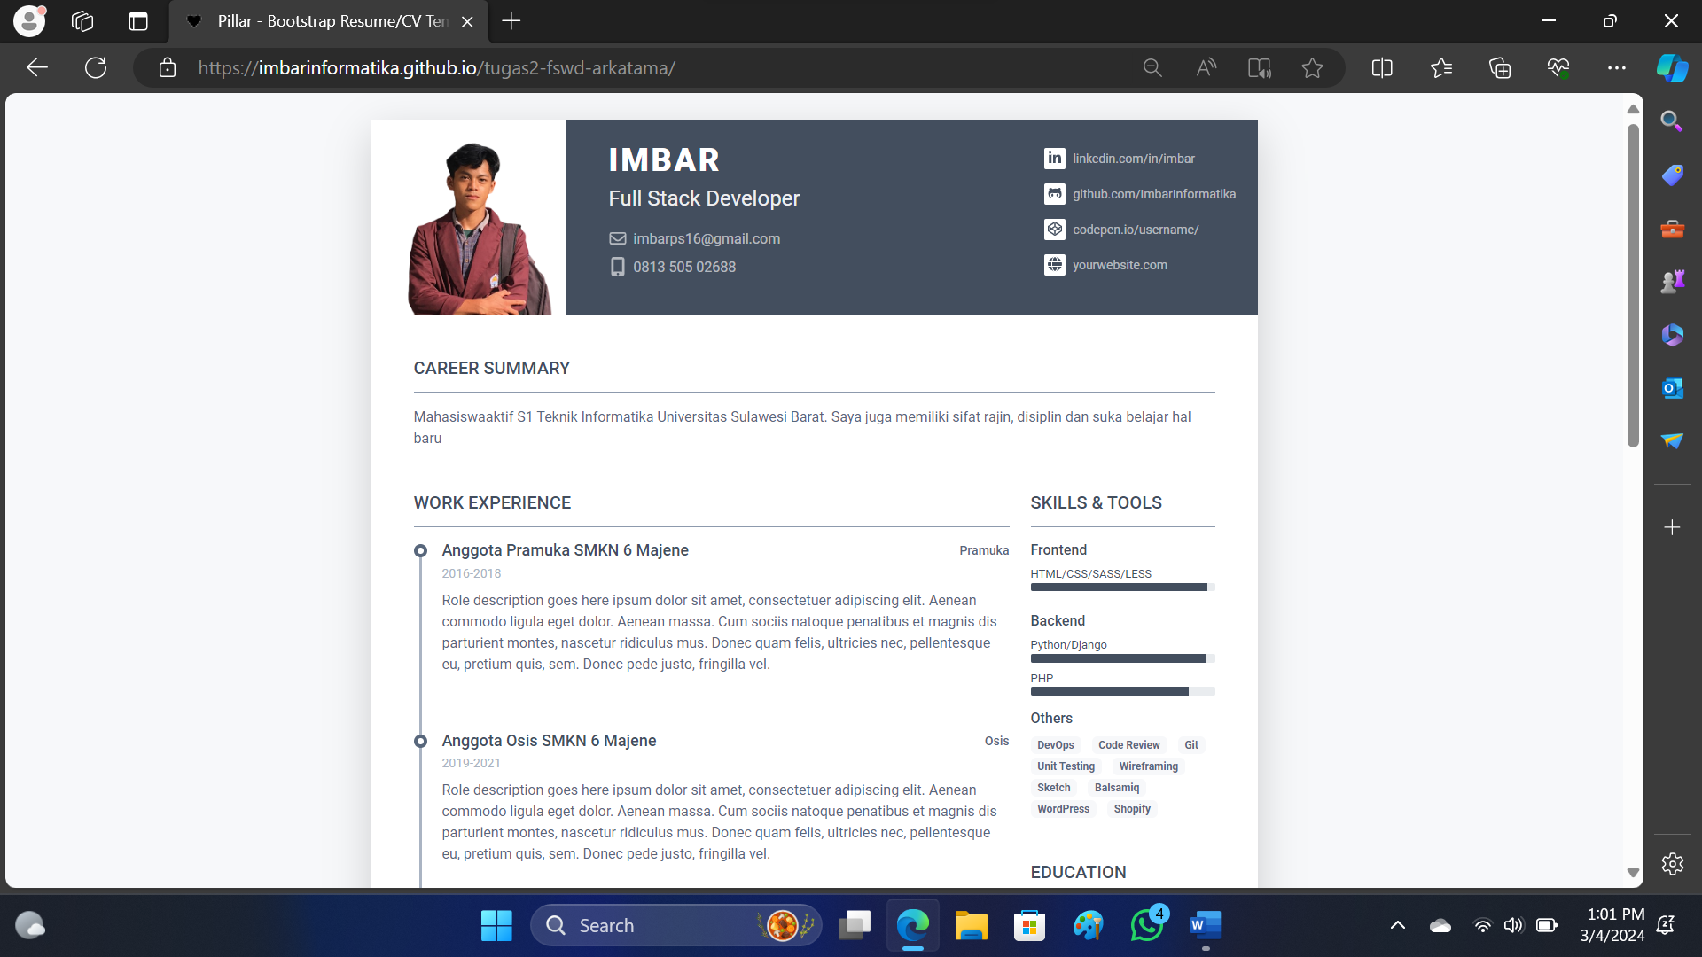

**Link Gitlab:** [imbar informatika / tugas2-fswd-arkatama · GitLab](https://gitlab.com/Imbartahir/tugas2-fswd-arkatama)

